Session 2026-2027

Vision:Dream of where you want. | Mission: Means to achieve Vision

Program Educational Objectives of the program (PEO): (broad statements that describe the professional and career accomplishments)
PEO1 | Preparation | P: Preparation | Pep-CL abbreviation  pronounce as Pep-si-lL easy to recall
PEO2 | Core Competence | E: Environment (Learning Environment) | Pep-CL abbreviation  pronounce as Pep-si-lL easy to recall
PEO3 | Breadth | P: Professionalism | Pep-CL abbreviation  pronounce as Pep-si-lL easy to recall
PEO4 | Professionalism | C: Core Competence | Pep-CL abbreviation  pronounce as Pep-si-lL easy to recall
PEO5 | Learning Environment | L: Breadth (Learning in diverse areas) | Pep-CL abbreviation  pronounce as Pep-si-lL easy to recall

Program Outcomes (PO): (statements that describe what a student should be able to do and know by the end of a program)
Keywords of POs:
Engineering knowledge,Problem analysis, Design/development of solutions,Conduct Investigations of Complex Problems, Engineering Tool Usage, The Engineer and The World,Ethics, Individual and Collaborative Team work,Communication, Project Management and Finance, Life-Long Learning

PSO Keywords: Cutting edge technologies, Research

“I am an engineer, and I know how to apply engineering knowledge to investigate, analyse and design solutions to complex problems using tools for entire world following all ethics in a collaborative way with proper management skills throughout my life.” to contribute to the development of cutting-edge technologies and Research.

Integrity: I will adhere to the Laboratory Code of Conduct and ethics in its entirety.

Name and Signature of Student and Date
(Signature and Date in Handwritten)

Session | 2024-25 (ODD) |  | Course Name | Web Technology Lab
Semester | 3 |  | Course Code | 23CT1301
Roll No | 14 |  | Name of Student | MANJIRI BHAISE
Practical Number |  | 6
Course Outcome |  | students will be able to create and manipulate arrays and objects, apply higher-order functions like `map()`, `filter()`, and `reduce()`, and process data efficiently using JavaScript
Aim |  | JavaScript — Arrays, Objects &amp; Higher-Order Functions.
Problem Definition |  | JavaScript — Arrays, Objects &amp; Higher-Order Functions  Sample Problem Statement: Model shopping-cart products as an array of objects and  implement add-to-cart, remove-item, and total-price calculation using map(), filter(),  and reduce().
Theory  (100 words) |  | JavaScript arrays and objects are used to store and manage data efficiently. An array stores multiple values in a single variable, while an object stores data in key-value pairs. Higher-order functions are functions that accept other functions as arguments or return functions. Common higher-order functions include map(), filter(), and reduce(). The map() method transforms array elements, filter() selects elements based on a condition, and reduce() calculates a single value from an array. These concepts help developers write simple, reusable, and efficient code. They are widely used in web development for handling and processing data.
Procedure and Execution  (100 Words) |  | Step 1: Create the JavaScript file  Step 2: Create the shopping cart  Step 3: Implement the Add operation  Step 5: Implement product-name extraction  Step 6: Calculate the total price  Step 7: Add a new product  Step 8: Remove a product  Step 9: Display product names and total  Step 10: Execute the program
CODE:
HTML
<!DOCTYPE html>
<html lang="en">
<head>
<meta charset="UTF-8">
<meta name="viewport" content="width=device-width, initial-scale=1.0">
<title>Shopping Cart</title>
<link rel="stylesheet" href="style.css">
</head>
<body>

<h1>Shopping Cart</h1>

<!-- Product List -->
<section id="product-list">
<!-- Products will be added using JavaScript -->
</section>

<!-- Shopping Cart -->
<aside id="cart">
<h2>Your Cart</h2>

<ul id="cart-list">
<!-- Cart items will appear here -->
</ul>

<p>Total: ₹<span id="total-price">0</span></p>
</aside>

<!-- JavaScript File -->
<script src="script.js"></script>

</body>
</html>
Css
body {
font-family: Arial, sans-serif;
background-color: #f4f6f9;
margin: 0;
padding: 30px;
display: flex;
flex-wrap: wrap;
gap: 30px;
align-items: flex-start;
}

h1 {
width: 100%;
text-align: center;
color: #333;
}

#product-list {
display: grid;
grid-template-columns: repeat(2, minmax(150px, 1fr));
gap: 20px;
flex: 2;
}

.product-card {
background-color: white;
border: 1px solid #ddd;
border-radius: 10px;
padding: 20px;
text-align: center;
box-shadow: 0 3px 8px rgba(0, 0, 0, 0.08);
}

.product-card h3 {
color: #333;
}

.product-card p {
font-size: 18px;
color: #555;
}

button {
background-color: #007bff;
color: white;
border: none;
padding: 10px 14px;
border-radius: 5px;
cursor: pointer;
}

button:hover {
background-color: #0056b3;
}

#cart {
flex: 1;
min-width: 220px;
background-color: white;
padding: 20px;
border-radius: 10px;
box-shadow: 0 3px 8px rgba(0, 0, 0, 0.08);
}

#cart h2 {
color: #333;
}

#cart-list {
padding-left: 20px;
}

#cart-list li {
margin-bottom: 15px;
}

#cart-list button {
background-color: #dc3545;
padding: 5px 8px;
margin-left: 5px;
}

#cart-list button:hover {
background-color: #a71d2a;
}

#total-price {
font-weight: bold;
color: #198754;
font-size: 20px;
}

@media (max-width: 600px) {
body {
padding: 15px;
}

#product-list {
grid-template-columns: 1fr;
}

#cart {
width: 100%;
}
}
JAVA SCRIPT
const products = [
{ id: 1, name: "Notebook", price: 40 },
{ id: 2, name: "Pen", price: 10 },
{ id: 3, name: "Bag", price: 500 },
{ id: 4, name: "Water Bottle", price: 150 }
];

let cart = [];

const productList = document.getElementById("product-list");
const cartList = document.getElementById("cart-list");
const totalPriceEl = document.getElementById("total-price");

function displayProducts() {
productList.innerHTML = products.map((product) => `
<div class="product-card">
<h3>${product.name}</h3>
<p>Price: ₹${product.price}</p>
<button onclick="addToCart(${product.id})">
Add to Cart
</button>
</div>
`).join("");
}

function addToCart(id) {
const item = products.find((p) => p.id === id);
cart.push(item);
displayCart();
}

function removeFromCart(id) {
const index = cart.findIndex((item) => item.id === id);

if (index !== -1) {
cart.splice(index, 1);
}

displayCart();
}

function calculateTotal() {
return cart.reduce((sum, item) => sum + item.price, 0);
}

function displayCart() {
cartList.innerHTML = cart.map((item, index) => `
<li>
${item.name} - ₹${item.price}
<button onclick="removeFromCart(${item.id})">
✖
</button>
</li>
`).join("");

totalPriceEl.textContent = calculateTotal();
}

displayProducts();
displayCart();
 |  | Output: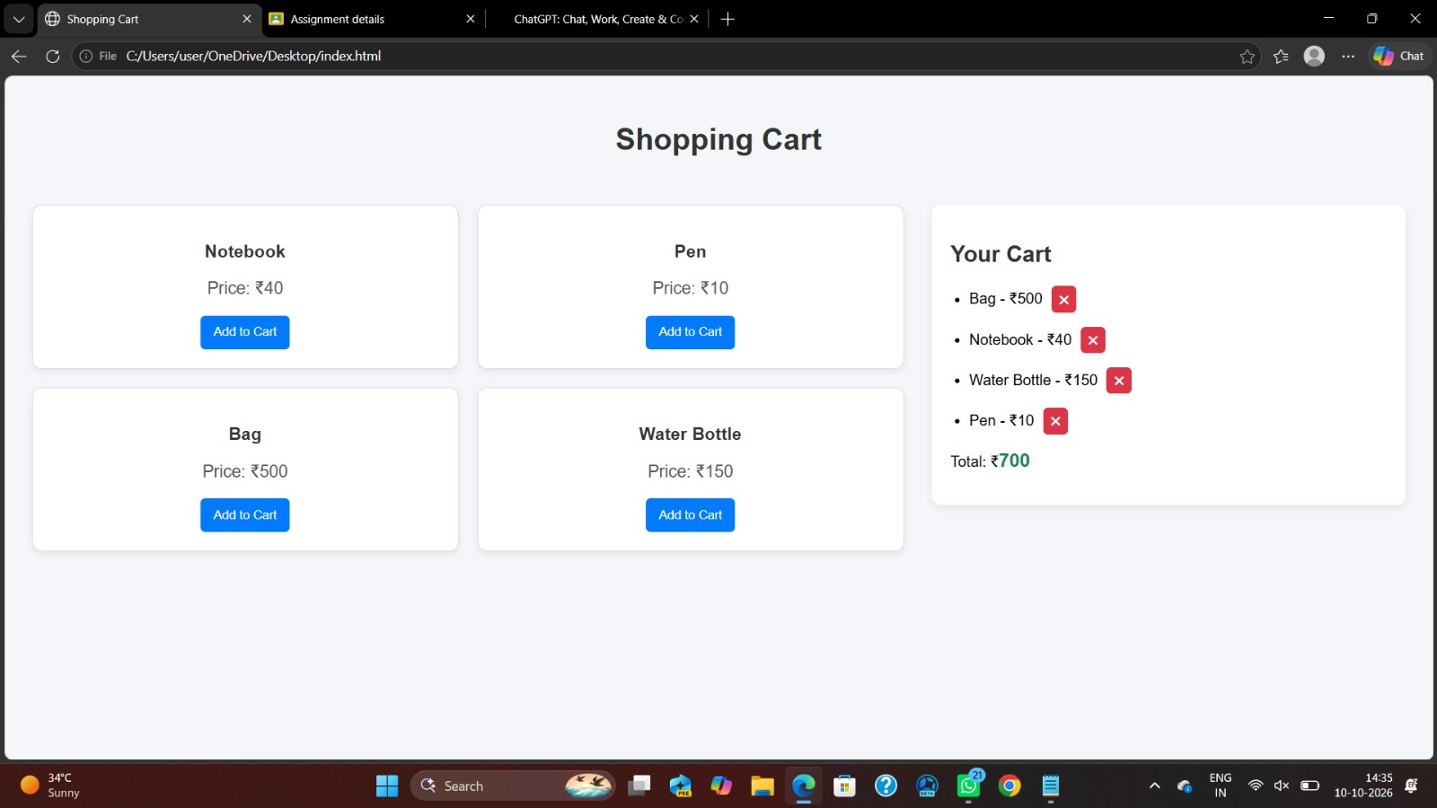
Link of student Github profile where lab assignment has been uploaded |  | https://github.com/manjiribhaise.com
Conclusion |  | The JavaScript program successfully models a shopping cart using an array of objects and  demonstrates the use of push(), map(), filter(), and reduce() to add products, remove  products, retrieve product names, and calculate the total price..
Plag Report (Similarity index < 12%) |  | - The submitted work was checked for similarity with existing sources. The similarity index is less than 12%, indicating that the content is largely original and independently prepared. Any minor similarities may be due to commonly used technical terms, programming syntax, or standard explanations related to JavaScript and form validation.
Date |  | 05/10/26

